DATE: 04/01/2019
INSTRUCTIONS FOR IMPLEMENTING DUAL DPM PCB AT FIELD FOR MODEL: CHAMP 600
SR. NO. | PICTURE | REMARK/ MEANING / INSTRUCTIONS
01 | 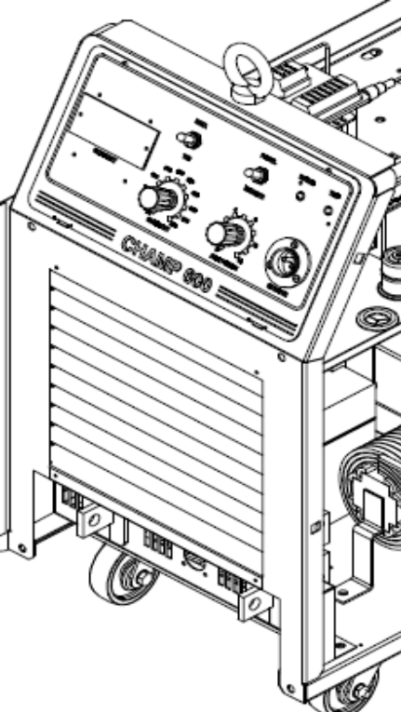 | REMOVAL OF EARLIER FRONT BEZEL PLATE:  - Disconnect connector 2 pin connectors CN3 & CN2-3 from DPM PCB  - Disconnect 4 pin connector CN1 connector from Mains On & trip LED PCB. Also remove PCB from bezel.  - Disconnect the connections & Remove Panel/Remote & MMA/TIG switch from front bezel  - Also Remove Remote connector socket from front bezel  - Remove potentiometer knob & cap from both potentiometers & then remove the pots from front bezel
02 | - Now remove the earlier front bezel plate from front cover  - New front bezel plate provided with the service kit is already with rivets mounted & with sticker.
SR. NO. | PICTURE | REMARK/ MEANING / INSTRUCTIONS
03 | 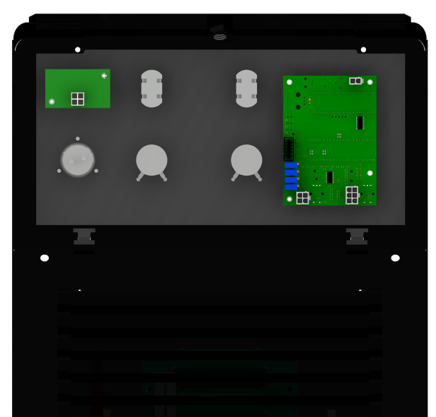 | ASSEMBLY OF NEW FRONT BEZEL PLATE:  - Mount new dual DPM PCB on new front bezel plate  - Mount Mains On & Trip LED PCB  - Mount Panel/Remote & MMA/TIG switch on front bezel plate  - Also mount Remote connector socket on front bezel plate  - Mount the pots on front bezel  Note: Only dual DPM PCB is new, all other components to be used from earlier front bezel plate
04 | 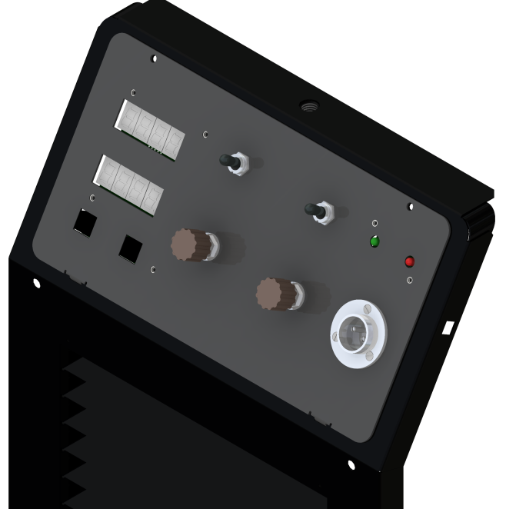 | CONNECTIONS AS PER CIRCUIT DIAGRAM:  - Reconnect 2 pin connector (Ferrule No: 19, 20) on new DPM PCB at CN3  - Reconnect 4 pin connector (Ferrule No: 14, 15, 17, 18) on Mains & Trip LED PCB at CN1  - Also complete the all remaining connections as per earlier & confirm w.r.t machine circuit diagram includes the connection for switches, pots & remote connector
SR. NO. | PICTURE | REMARK/ MEANING / INSTRUCTIONS
05 | 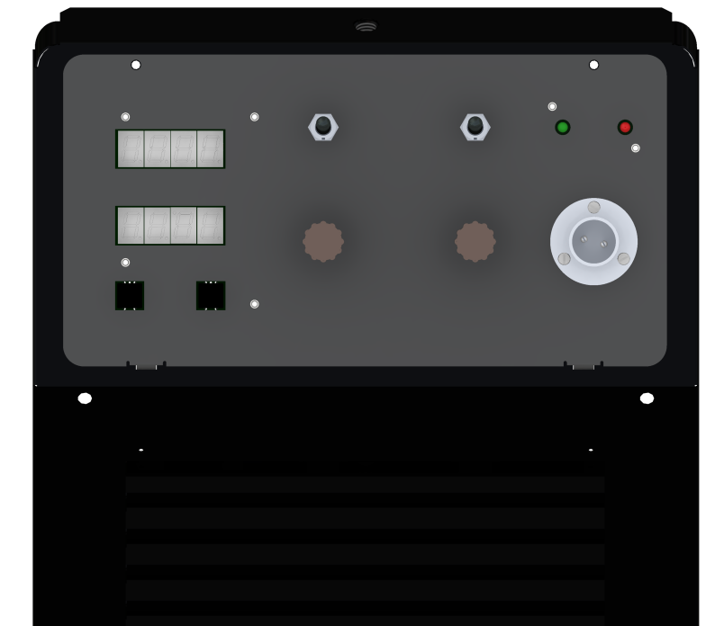 | - Remove wire connections of 2 pin connector (Ferrule No: 16, 25) from shunt  - Use wire boom provided with the service kit:  - Connect the 6 pin connector to CN2 of new DPM PCB.  - Connect Ferrule no 16 & 25 wires to shunt referring wiring diagram  - Connect Ferrule no 24 wire to +o/p of power source  - Connect Ferrule no 42 wire to middle terminal of Panel/ Remote Switch as shown in wiring diagram

S17.01.003.1441: SERVICE KIT FOR IMPLEMENTING DUAL DPM PCB IN MODEL: CHAMP 600
Item Seq. | Item | Description | UOM | Qty
10 | 081.06.008.2991 | FRONT BEZEL FABRICATED FOR MODEL: CHAMP 600 WITH DUAL DPM PCB AS PER DRAWING NO: C379-34-05 | NOS | 1
20 | 041.11.002.0580 | FRONT BEZEL STICKER FOR MODEL: CHAMP 600 WITH DUAL DPM PCB AS PER DRAWING NO: C379-34-06 | NOS | 1
30 | 011.03.006.0001 | RIVET NUT M3 X 8MM LONG,PART NUMBER-CESM3X8R, AS PER DRAWING NUMBER- CESRM3, MAKE- CONWELD ENGERIING SERVICES. | NOS | 6
40 | 017.01.008.0287 | DPM PCB (PA79/557/B) ASSEMBLY AS PER CKT DIA CK79/868/B WITH PU COATING ON BOTH SIDE WITH BRUSH FOR 600 MACHINE (DPM WITH SET CURRENT, ACTUAL CURRENT & VOLTAGE WITH ARC ON TIME & RESET). | NOS | 1
50 | 026.01.043.0003 | M.S. ZINC PLATED HEX NUT M3 | NOS | 4
60 | 026.01.080.0084 | CHROME PLATED M3 PLAIN WASHER | NOS | 8
70 | 026.01.003.0034 | M.S.ZINC PLATED SLOTTED CHEESE HEAD SCREW M3x8MM | NOS | 4
80 | 021.01.007.1153 | ADDITIONAL WIRE BOOM FOR IMPLEMENTING DUAL DPM PCB FOR MODEL: CHAMP 600 AS PER DRG. NO: CWH79-34-10 | NOS | 1

Additional Features added with Dual DPM PCB in model: Champ 600
- Digital Panel Meter (dual display) to display the set current and actual current & voltage while welding:

  - Earlier only actual current was displayed on DPM, now dual DPM will show set current as well as actual current.

  - Actual voltage will also displayed with Dual DPM

- Available with display of Arc on time with option of reset.

  - Extra keys Time & Reset are added on front panel

  - When Time key of arc on time is pressed, one display shows arc on message & other display shows arc on time counter in hour, Min

  - Reset key is used to reset the arc on time.

Prepared By, Approved By,
Neeta Solanki Sachin Dobhada

